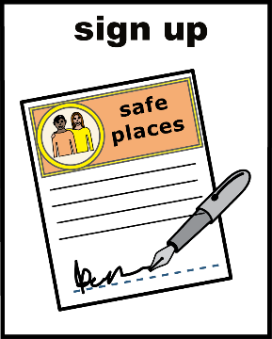
Give your permission to take part in the Hounslow Adult Safeguarding Forum
If you would like to join us to talk about your safeguarding experiences, we need your permission.
If you are happy to take part, please tick the Yes box.

 | 
 |  | I have read and understood this document.
 |  | I know that I do not have to take part.
 |  | I know I can refuse to answer questions if I want or leave at any time. If I decide to do that, then any information I have already given will not be used or shared and will be destroyed straight away.
 |  | I agree that my information can be used in the report given to Hounslow Council – but it won’t say my name.
 |  | I understand that any personal information that can identify me will not be shared beyond the project team.
 |  | If I say something that is putting myself or someone else in danger, I understand this may have to be reported.
 |  | I agree to take part in this project and to be contacted by Healthwatch Hounslow.

Please tick all that apply | Would you prefer?
o | Regular face to face group meetings
o | Regular online meetings
o | Face to face interview
o | Telephone interview
o | Questionnaire

Your contact details
 | Please enter your details
Name
Telephone Number
Email (if you have one)
Today’s date
Your experience:  You have experienced safeguarding yourself  You are a Carer / Family / Friend | o  o


Please send this form to:
Email: viviane@healthwatchhounslow.co.uk
or
Post: to Viviane Walker, Freepost RTHC-JCSH-ERTE, Healthwatch Hounslow, 45 St. Mary’s Road, Ealing, W5 5RG

